LAB 5

Implement the “bought relationship between User & Item from Caveat Emptor:

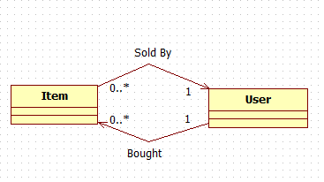

Exercise the “performance Fetching strategies against the relationship.

Do the Join, Batch Size & SubSelect fetching Strategies.

NOTE: You can use the Hibernate Annotations. No need to “manually” implement Join OR SubSelect, for example.

Lab_5_XXX.zip has been provided. A new project should be created for all strategies:

Lab_5_Join, Lab_5_Batch, Lab_5_SubSelect.

All of the data and “exercise” code is provided. It is necessary to implement the strategies.

The Demos are good reference.

You also need to write a document explaining the output results W/R to the particular strategy.

One document is sufficient, name it Lab_5_explanation.docx